Answers
Task 1
1. What type of user interface does a smartphone have?
Graphical User Interface (GUI).
Also to some extent a voice activated interface.
2. List three differences between a smartphone and a desktop PC that affect how the user interface operates.
Answers could include:
- A smartphone has a smaller screen so can fit less graphical objects on it than a PC screen
- A smartphone may be in a pocket/bag so needs to get the users attention for alarms/phone call etc. This may be using audible alerts or by vibrating.
- There is no physical keyboard on a smartphone so it needs a virtual (software) keyboard to enter text (this is a responsibility of the operating system)
- Smartphones have touch-screens for navigation rather than a mouse
- Smartphones are small and easily moved around so can use tilt sensors/accelerometers as input devices
- Smartphones need to be more durable and portable than a PC as they are carried around – it is harder for them to have peripheral devices due to the risk of damage, so these features must be self-contained
3. Describe how a user interacts with a smartphone to do various tasks.
Consider both inputs and outputs.
Inputs include:
- voice instructions to dial
- typing text messages
- speaking to enter text messages
- pressing buttons to switch on or off silent/vibrate mode
- touching the screen to select icons/apps
- swiping to move between screens
- gestures such as pinch to zoom
- lifting the phone to answer a call
- shaking the device to undo
- making use of the camera
- bio-sensors such as heart-rate
- use of GPS to track distance walked/run
Outputs include:
- screen
- speaker for ringtone, alarms & music
- vibrations for notifications

Task 2
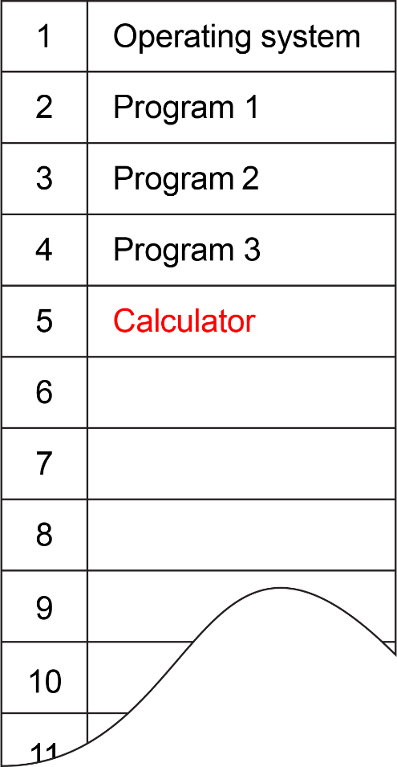
1. The diagram shows a section of RAM.
Currently, the operating system and three programs are stored in the RAM
(a) The user double clicks an icon to run a program named “Calculator”.
Describe what the operating system now does and make any suitable alterations to the diagram of RAM.
The operating system loads the calculator into a free part of RAM.
The operating system will add the calculator to the queue of running programs.
Each program will get a small amount of time to run on the CPU.
[Note that the calculator can be stored in any of the free locations in RAM. Also note that the operating system and programs are labelled with locations in this diagram. In reality, memory addresses are used and each program would require a range of addresses.]
(b) Program 3 attempts to access a memory address inside location 2 (where Program 1 is located).
Explain what the operating system does.
The operating system will prevent Program 3 from accessing this area to avoid any corruption of the data (if a write occurs) or to avoid any security risk (if a read or write occurs).

The second question relies on students, or at least the teacher, to be able to run the task manager on their computers. If you do not have access to this feature, you may have access to a Raspberry Pi or Linux in a virtual machine. If both you and students do not have any access to any type of task manager, delete this part of the task for students.
2. Run the task manager on your computer.
On Windows computers, this can be carried out by pressing CTRL-SHIFT-ESC.
On Mac computers, load the Activity Monitor, found in Applications folder > Utilities folder
On Linux computers, make use of the “ps” command or “top” command in a terminal window.
If you cannot access your task manager, activity monitor or linux commands, your teacher may be able to demonstrate these to you.
(a) How many programs are currently loaded in memory?
Answers depend on current programs open.
Students should be shown that many more tasks/processes are running on a computer than just the programs shown.
(b) Whilst viewing your task manager, explain what happens when a program is opened, running and close.
The program goes to the top of the list (assuming it is ordered by CPU usage).
This is because it requires lots of CPU time to load the program code into memory.
Once loaded into memory, the program will remain on the list of running tasks/programs.
Its CPU and RAM usage will alter depending on the processing required by the program.
When the program is closed, a short time later it will be removed from the list of running programs.
Task 3
An operating system is responsible for file management.
(a) State at least three features that the operating system allows the user to carry out with files and folders or directories.
- Create a file/folder/directory
- Delete a file/folder/directory
- Create a folder/directory hierarchy (sub-folders/sub-directories)
- Rename a file/folder/directory
- Move a file/folder/directory
(b) Describe the processes that an operating system undertakes when a programmer writes a program to write a line of text to a file located on a magnetic hard disk.
- The operating system determines where on the disk the file will be stored.
- The operating system tells the drive head where to move.
- The operating system waits until the disk has rotated to the correct location.
- The file is then written to.

